WORKING RELATIONSHIPS
There are several characteristics that make up good, healthy working relationships:
Trust – This is the foundation of every good relationship. When you trust your team and colleagues, you form a powerful bond that helps you work and communicate more effectively. If you trust the people you work with, you can be open and honest in your thoughts and actions, and you don’t have to waste time and energy “watching your back.”
Mutual Respect – When you respect the people that you work with, you value their input and ideas, and they value yours. Working together, you can develop solutions based on your collective insight, wisdom and creativity.
Mindfulness – This means taking responsibility for your words and actions. Those who are mindful are careful and attend to what they say, and they don’t let their own negative emotions impact the people around them.
Open Communication – We communicate all day, whether we’re sending emails or meeting face-to-face. The better and more effectively you communicate with those around you, the richer your relationships will be. All good relationships depend on open, honest communication.
Although we should try to build and maintain good working relationships with everyone, there are certain relationships that deserve extra attention – for instance Clients and customers. Although you may not be able to keep everyone happy 100 percent of the time, maintaining honest, trusting relationships with your customers can help you ensure that if things do go wrong, damage is kept to a minimum.

TIPS ON BUILDING BETTER WORK RELATIONSHIPS:
Develop Your People Skills – Good relationships start with good people skills. Identify Your Relationship Needs – Do you know what you need from others? And do you know what they need from you? These needs can be instrumental in building better relationships.
Schedule Time to Build Relationships – Devote a portion of your day toward relationship building, even if it’s just 20 minutes, perhaps broken up into five-minute segments. For example, you could pop into someone’s office during lunch, reply to people’s postings on Twitter or ask a colleague out for a quick cup of coffee. These little interactions help build the foundation of a good relationship, especially if they’re face-to-face.
Appreciate Others – Show your appreciation whenever someone helps you. Everyone, from your boss to the office cleaner, wants to feel that their work is appreciated. So, genuinely compliment the people around you when they do something well.
Be Positive – Positivity is attractive and contagious, and it will help strengthen your relationships with your colleagues. No one wants to be around someone who’s negative all the time.
Manage Your Boundaries – All of us want to have friends at work, but, occasionally, a friendship can start to impact on our jobs, especially when a friend or colleague begins to monopolize our time. If this happens, it’s important that you’re about your boundaries, and that you know how much time you can devote during the work day for social interactions.

Avoid Gossiping – Office politics are major relationship killers at work. If you’re experiencing conflict with someone in your group, talk to them directly about the problem. Gossiping about the situation with other colleagues will only exacerbate the situation, and will cause mistrust and animosity between you.
Listen Actively – People respond to those who truly listen to what they have to say. Focus on listening more than you talk, and you’ll quickly become known as someone who can be trusted.

EQUALITY & DIVERSITY
Equality
The Equality Act came into force from October 2010 providing a modern, single legal framework with clear, streamlined law to more effectively tackle disadvantage and discrimination.
The following are classified as ‘protected characteristics’, for which a person cannot be discriminated for:
- Age
- Disability
- Gender reassignment
- Marriage and civil partnership
- Pregnancy and maternity
- Race
- Religion and belief
- Sex
- Sexual orientation
Under the Act people are not allowed to discriminate, harass or victimise another person because they have any of these protected characteristics. There is also protection against discrimination where someone is perceived to have one of the protected characteristics or where they are associated with someone who has a protected characteristic.
Diversity
Diversity aims to recognise, respect and value people’s differences to contribute and realise their full potential by promoting an inclusive culture for everybody.
People with good relationships not only accept diverse people and opinions, but they welcome them. For instance, when your friends and colleagues offer different opinions from yours, you take the time to consider what they have to say, and factor their insights into your decision making.
This would include recognising people’s limitations and treating them accordingly. For instance, you would not expect a new apprentice to hang a door on his own – you would put him/her with an experienced joiner who would mentor them. Likewise you would not expect him/her to understand the many technical and trade expressions until they had a lot more experience/training in the job.
You could also consider that many workers do not have English as their first language – so it is important to make suitable arrangements (eg translation) in terms of health and safety procedures, etc.
The Equality and Human Rights Commission, researched the construction sector and found that the following could be achieved by implementing good equality and diversity practice:
- Efficiency savings through improved staff retention
- A wider pool of talent available to the Industry from under-represented groups
- A more diverse supply chain with better support for small business
- Improved on-site working relationships based on respect for everyone’s
differences.
See a copy of the full report here.
The CITB have launched the BeFair framework to give employers a structured way to develop and embed fairness, inclusion and respect (FIR) in their company. You can find more details here.
Communication of work activities
There are many opportunities to communicate with relevant people about work activities. These include:

Face to Face Written Visual
Prework briefings Emails Signs / Posters
Inductions Memos Noticeboards
Toolbox Talks Method Statements Drawings

Different types of project related information can be communicated via any means. The level of detail needed may sometimes dictate which communication method is used – as well as what the degree of urgency is.

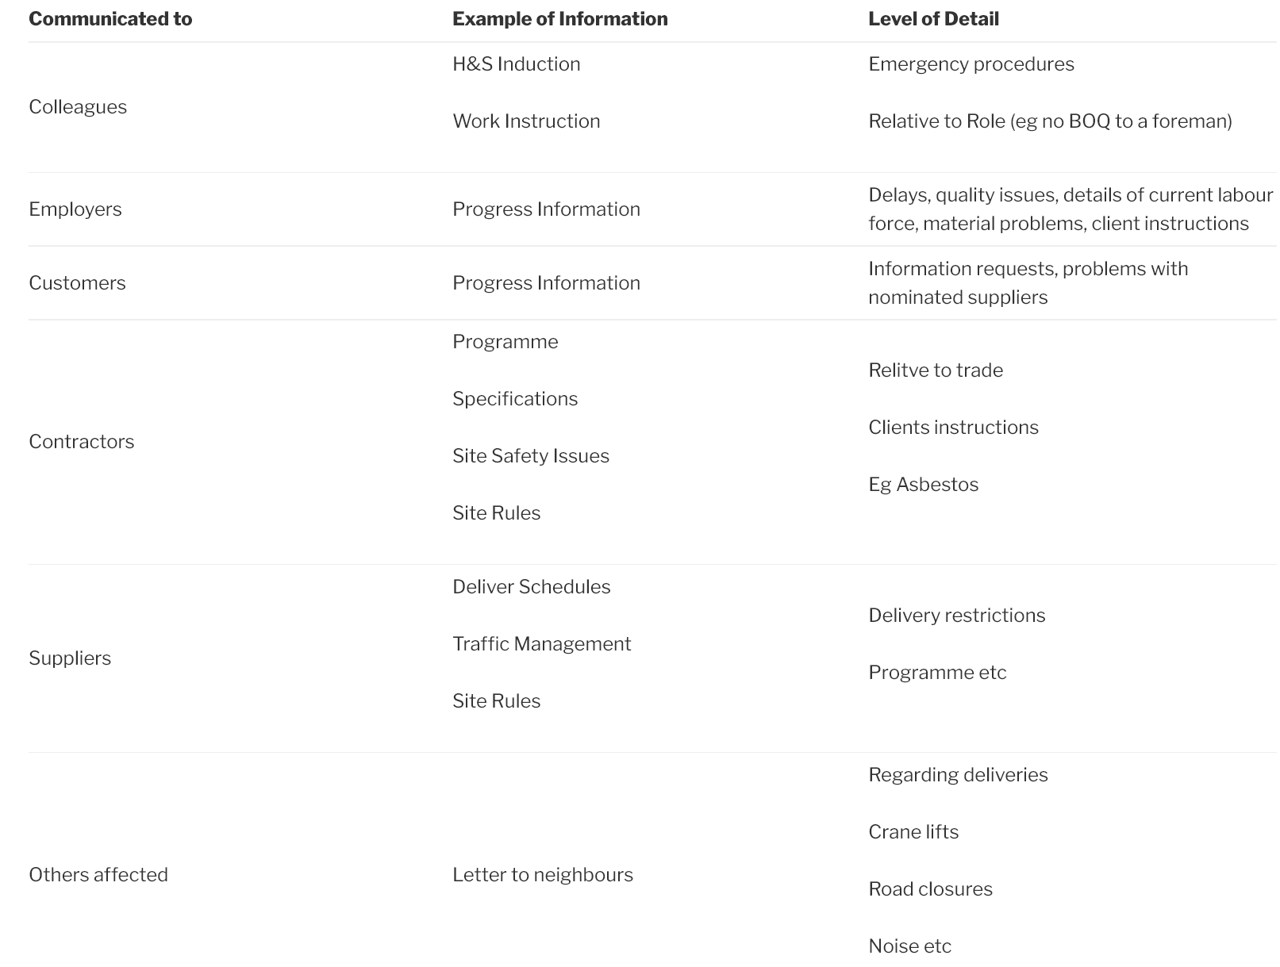
If relevant people are not informed with the right degree of urgency – work can slip behind programme. This can cause delays to the following trades and other critical path items. All of which will have a negative cost implication.

Offering Advice and Encouraging Questions
This is done firstly at induction when you ask people if there is anything they don’t understand, also at pre work briefings and toolbox talks.
As part of your everyday role you will be talking to people on site or when they call into the site office. Having an Open Door Policy will encourage people to come to you if they have any problems or questions. When questions are asked, always answer honestly and openly. Don’t be impatient or sarcastic as this will discourage them from asking questions next time.
Different ways to offer advice and help could include:
Progress – Generally discussed at informal morning meetings or formal site meeting. Could also be done on a one to one basis in the office or out on site; through reports that can be emailed or presented.

Results – Generally discussed at informal morning meetings or formal site meeting. Could also be done on a one to one basis in the office or out on site; through reports that can be emailed or presented, through signs that can be displayed on noticeboards.
Achievements – Generally discussed at informal morning meetings or formal site meetings. Could also be done on a one to one basis in the office or out on site; through reports that can be emailed or presented; through signs that can be displayed on noticeboards.
Occupational problems – Generally done through one to one discussion on site but can also be done in meetings or by e-mail or phone calls.
Occupational opportunities – Generally done at appraisals but also by one to one conversation if opportunity arises in the meantime.
Health and safety requirements – Firstly at induction when site rules and emergency procedures are explained and RAMS discussed and signed for; also at pre-work briefings and toolbox talks; can also be done on site during walk around’s.
Co-ordinated work -. Generally discussed at daily informal meetings with subcontractor supervisors but also discussed on site and at formal meetings.

Clarifying Proposals
Occasionally, proposals will need clarifying with relevant people and alternative suggestions discussed. Ideal ways to do this will be to sit down with the proposer and thoroughly investigate the issue with them. This could include online research for clarification if necessary. Evaluation of the benefits, either in terms of cost, progress, health and safety or sustainability would also be discussed and then any alternative proposals could be suggested.
As well as these suggestions being made by phone, it is recommended they be backed up with an e-mail, by e-mail or in a meeting and the research results used to reinforce the proposal

Resolving Differences of Opinion
Conflict is pretty much inevitable when you work with others. People have different viewpoints and, under the right set of circumstances, those differences escalate to conflict. Understanding and appreciating the various viewpoints involved in conflict are key factors in its resolution. The important thing is to maintain a healthy balance of constructive difference of opinion, and avoid negative conflict that’s destructive and disruptive.
Resolving conflict requires respect and patience. The three-stage process below is a form of mediation process which can minimise offence and maintain goodwill, trust and respect among your team:

Step 1: Prepare for Resolution
- Acknowledge the conflict – The conflict has to be acknowledged before it can be managed and resolved.
- Discuss the impact – As a team, discuss the impact the conflict is having on team dynamics and performance.
- Agree to a cooperative process – Everyone involved must agree to cooperate. If someone wants to win more than resolve the conflict, you may find yourself at a stalemate.
- Agree to communicate – The people involved need to talk about the issue and discuss their strong feelings. Active listening is essential, because to move on you need to really understand where the other person is coming from.

Step 2: Understand the Situation
Take time to make sure that each person’s position is heard and understood. Remember that strong emotions are at work here so you have to get through the emotion and reveal the true nature of the conflict. Do the following:
Clarify positions – each position needs to be clearly identified and articulated by those involved – this helps the team see the facts more objectively and with less emotion.
Discuss facts, assumptions and beliefs underlying each position – not only can this reveal new areas of agreement, it can also reveal new ideas and solutions that make the best of each position and perspective. Take care to remain open, rather than criticize or judge the perceptions and assumptions of other people. Everyone needs to feel heard and acknowledged if a workable solution is to be reached.
Consider, then convene back as a team – Give people time to re-assess. This allows people to step away from their emotions and see the issue more objectively.

Step 3: Reach Agreement
Now that all parties understand the others’ positions, the team must decide what decision or course of action to take. With the facts and assumptions considered, it’s easier to see the best of action and reach agreement.

